|  |  |  |  |  |  |
| --- | --- | --- | --- | --- | --- |
| Date | 28-Nov-22 | | | Tester Name | Mayuri Patel |
| Environment | Penfax - Test | | | Login used |  |
| Operating System | Windows | Version: | Update: | | |
| Software Used | Edge | Version: | Update: | | |
| Not Applicable | Version: | Update: | | |
| Release version | 22.4.1 | | | | |
| Title | Death | | | | |
| Test Type | Regression | | | | |
| Test Scenario | Process a death payout to non-spouse beneficiary | | | | |
|  |  | | | | |
| Expected Results | Deceased member’s investment account should show $0 once death payout is processed.  Benefit Receipt should be generated under beneficiary’s account.  PEPP Payment to Non-Member letter and T4A slip should be generated for beneficiary. | | | | |
| Pass/Fail | Pass | | | JIRA# | N/A |

Describe your steps with screenshots:

1. In PENFAX5 do a search for deferred survivor member. Click on the stakeholder ID.

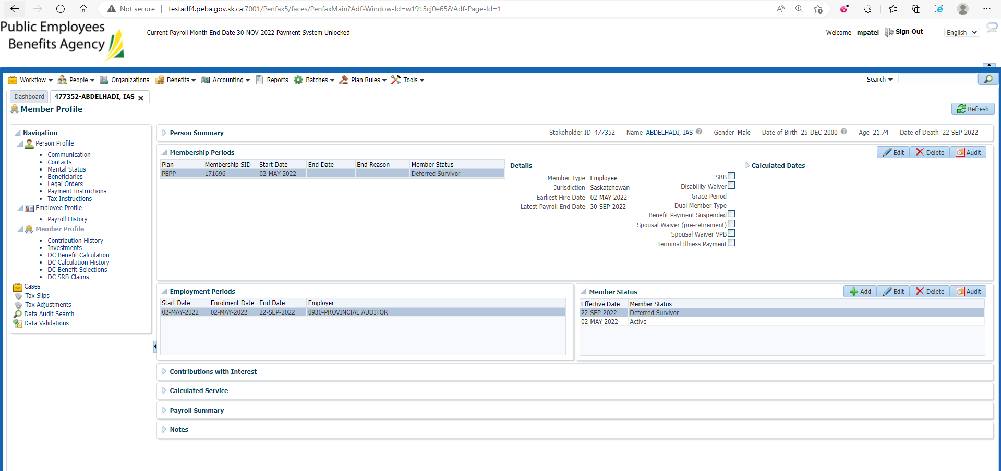

1. Click DC Benefit Selection. Click Add.

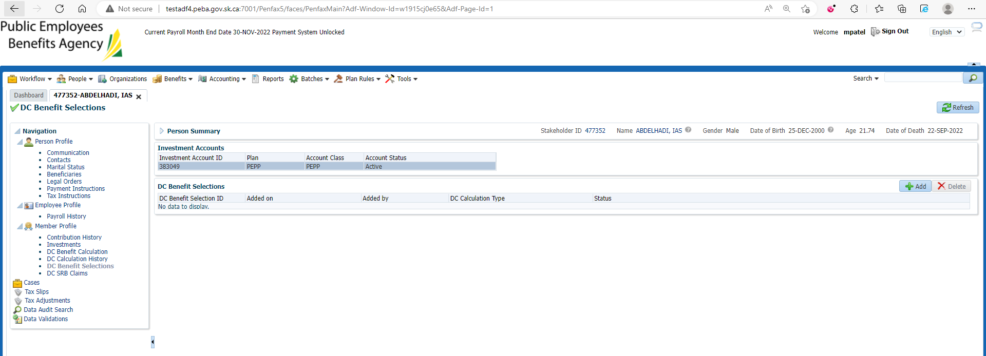

1. Make sure Date of Death is populated. Click Next.

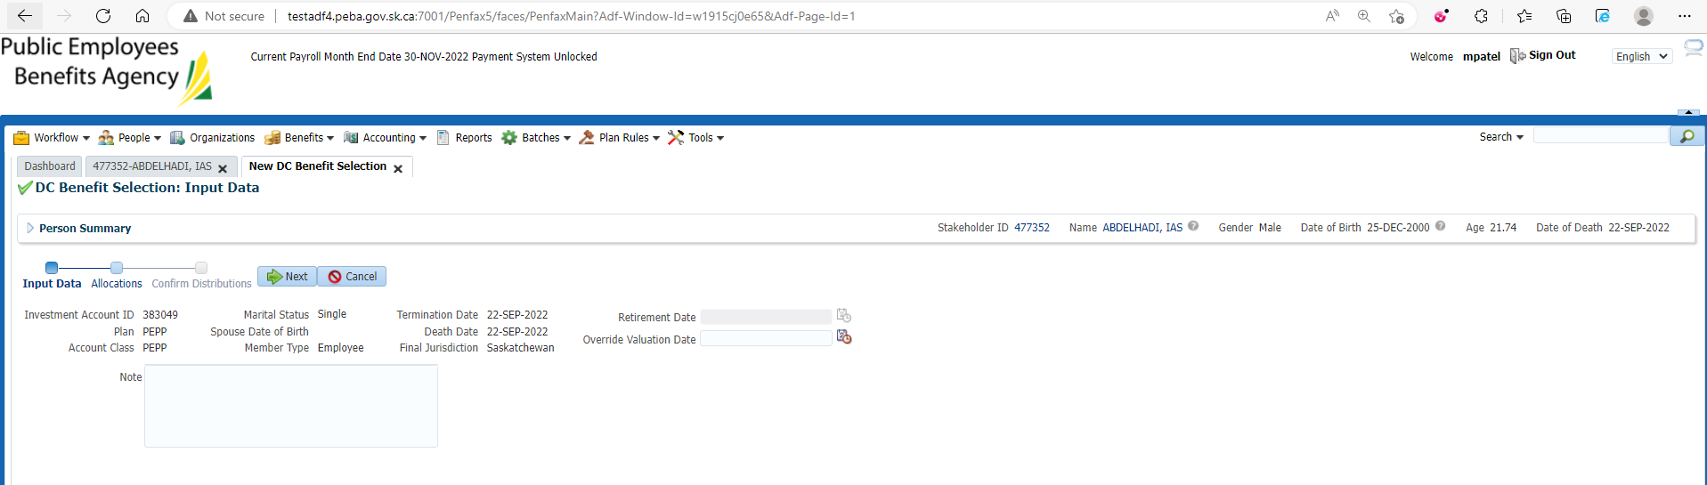

1. Under Allocation Click Add.

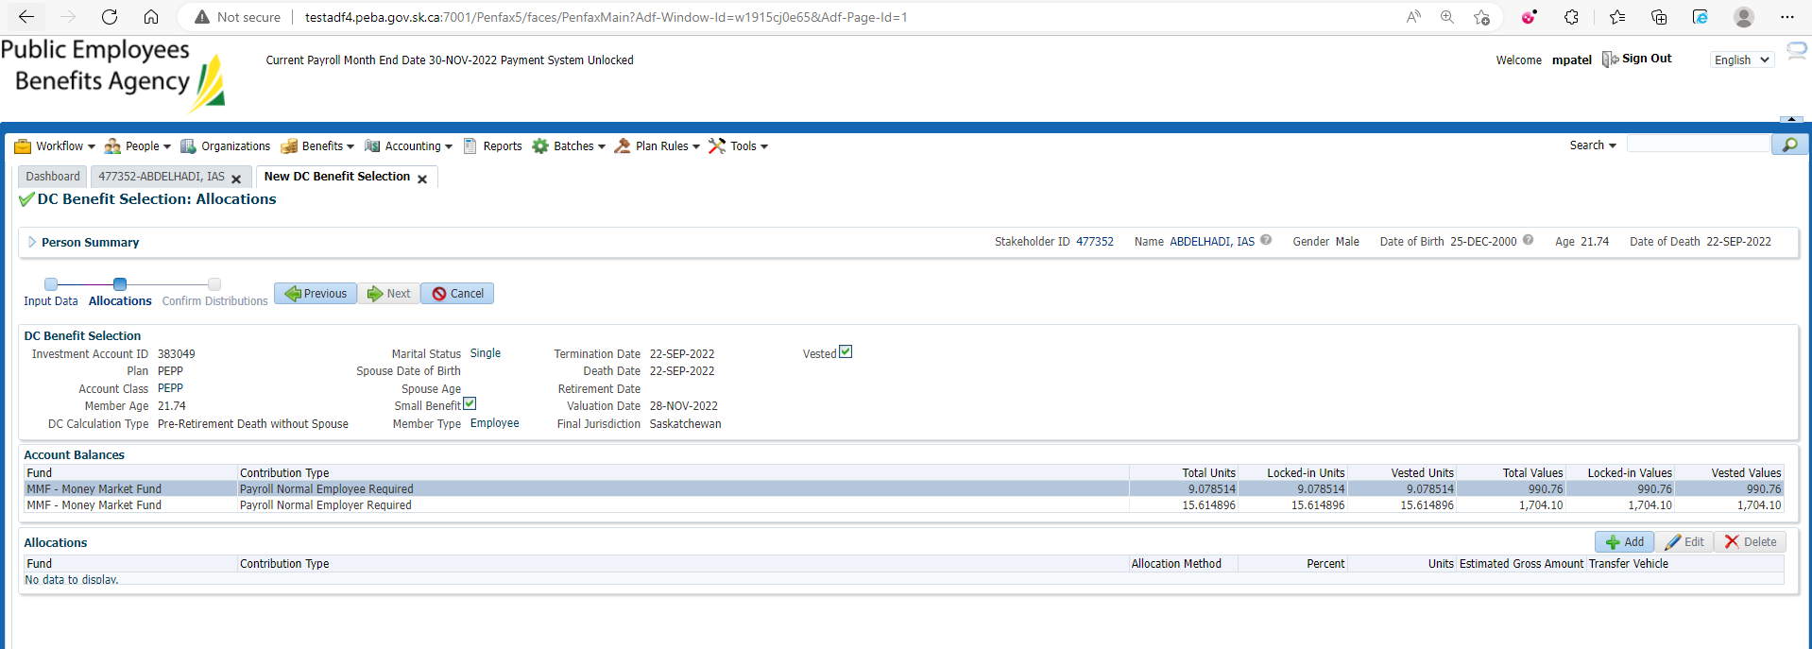

1. Select a fund from the dropdown. Select the contribution type. Change allocation method to Percent. Input 100%. Under transfer vehicle select cash. Click Save. You will need to repeat for each fund and each contribution type. Click Next.

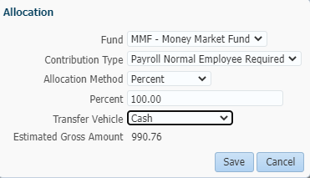

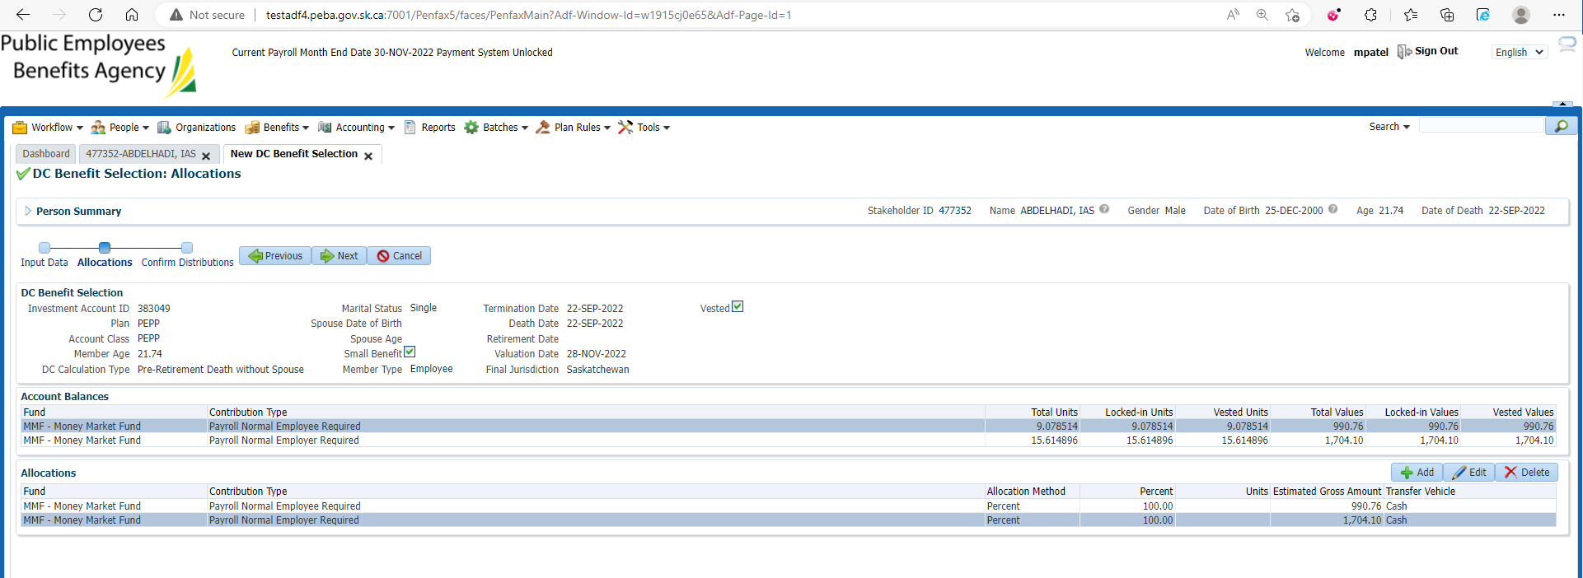

1. Under Onetime amounts you will need to attach payment instructions – set to cheque and home address. Under tax instructions add basic instructions. You need to set up instructions for each beneficiary receiving a payment.

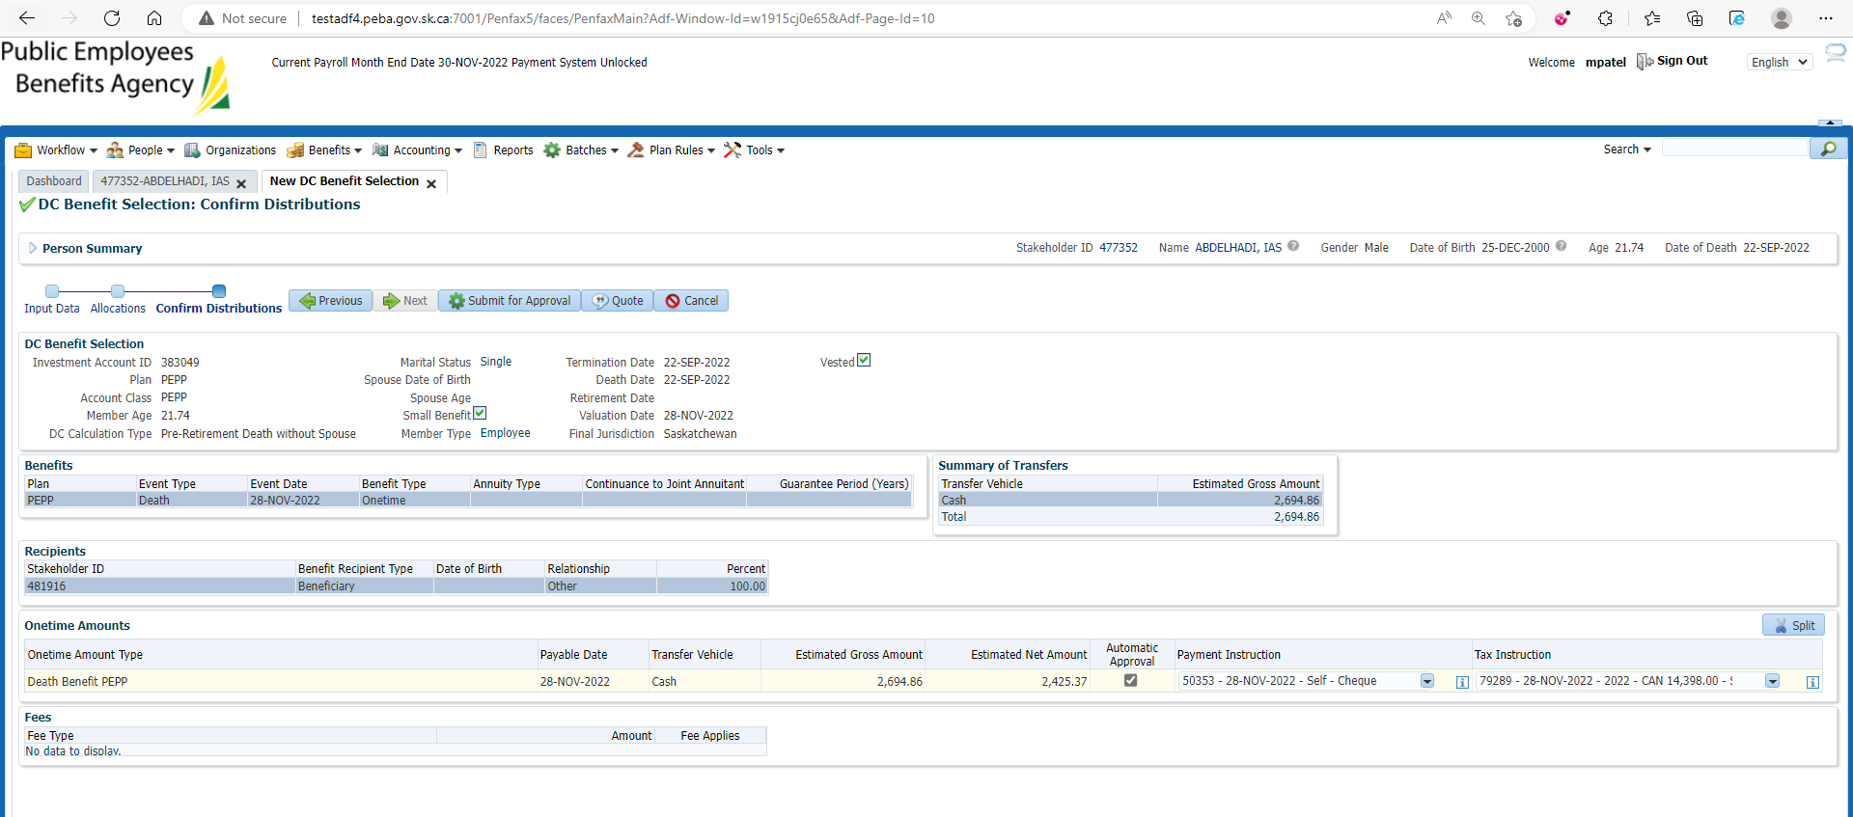

1. Click submit for approval.



1. Approve the payment.

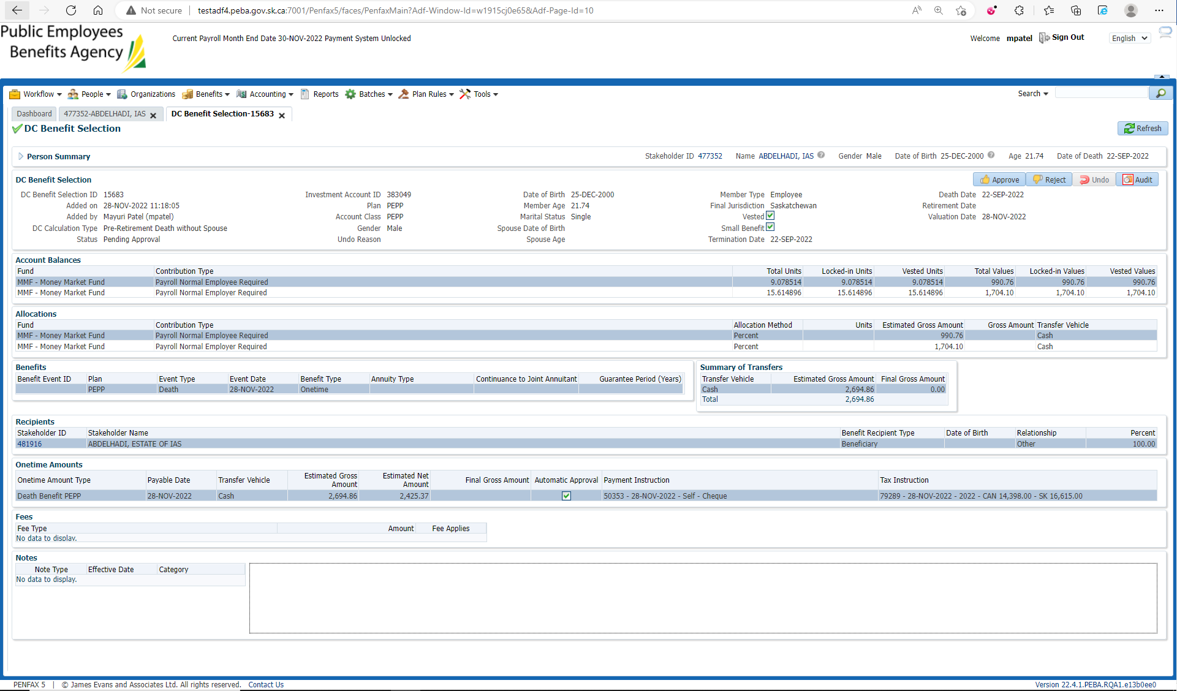

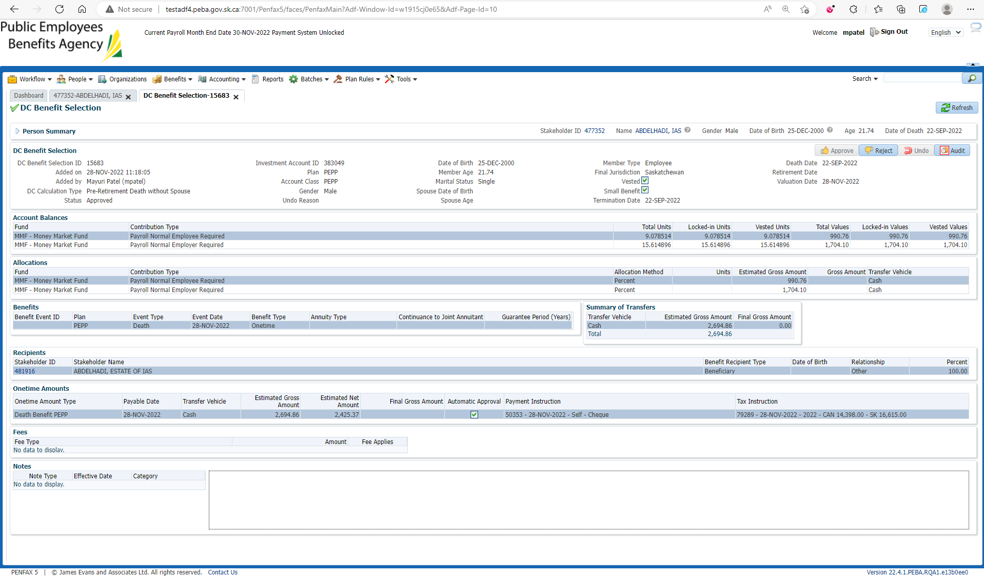

1. Approved Benefit Selection can be seen under Member Profile -> DC Benefit Selection.

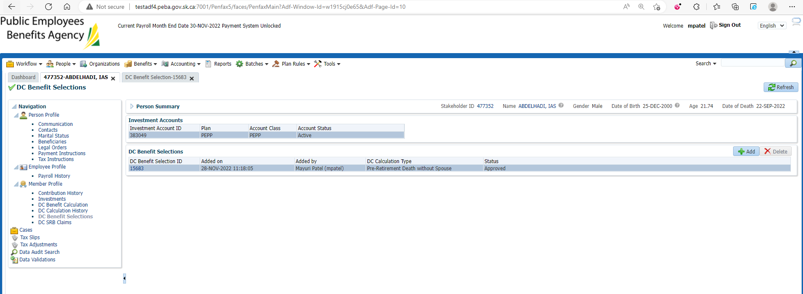

1. Wait for overnight batches to run.

Bring up the deceased member.

Click on Investments.

Make sure the account balance is now 0.

Make sure the account status is now inactive.

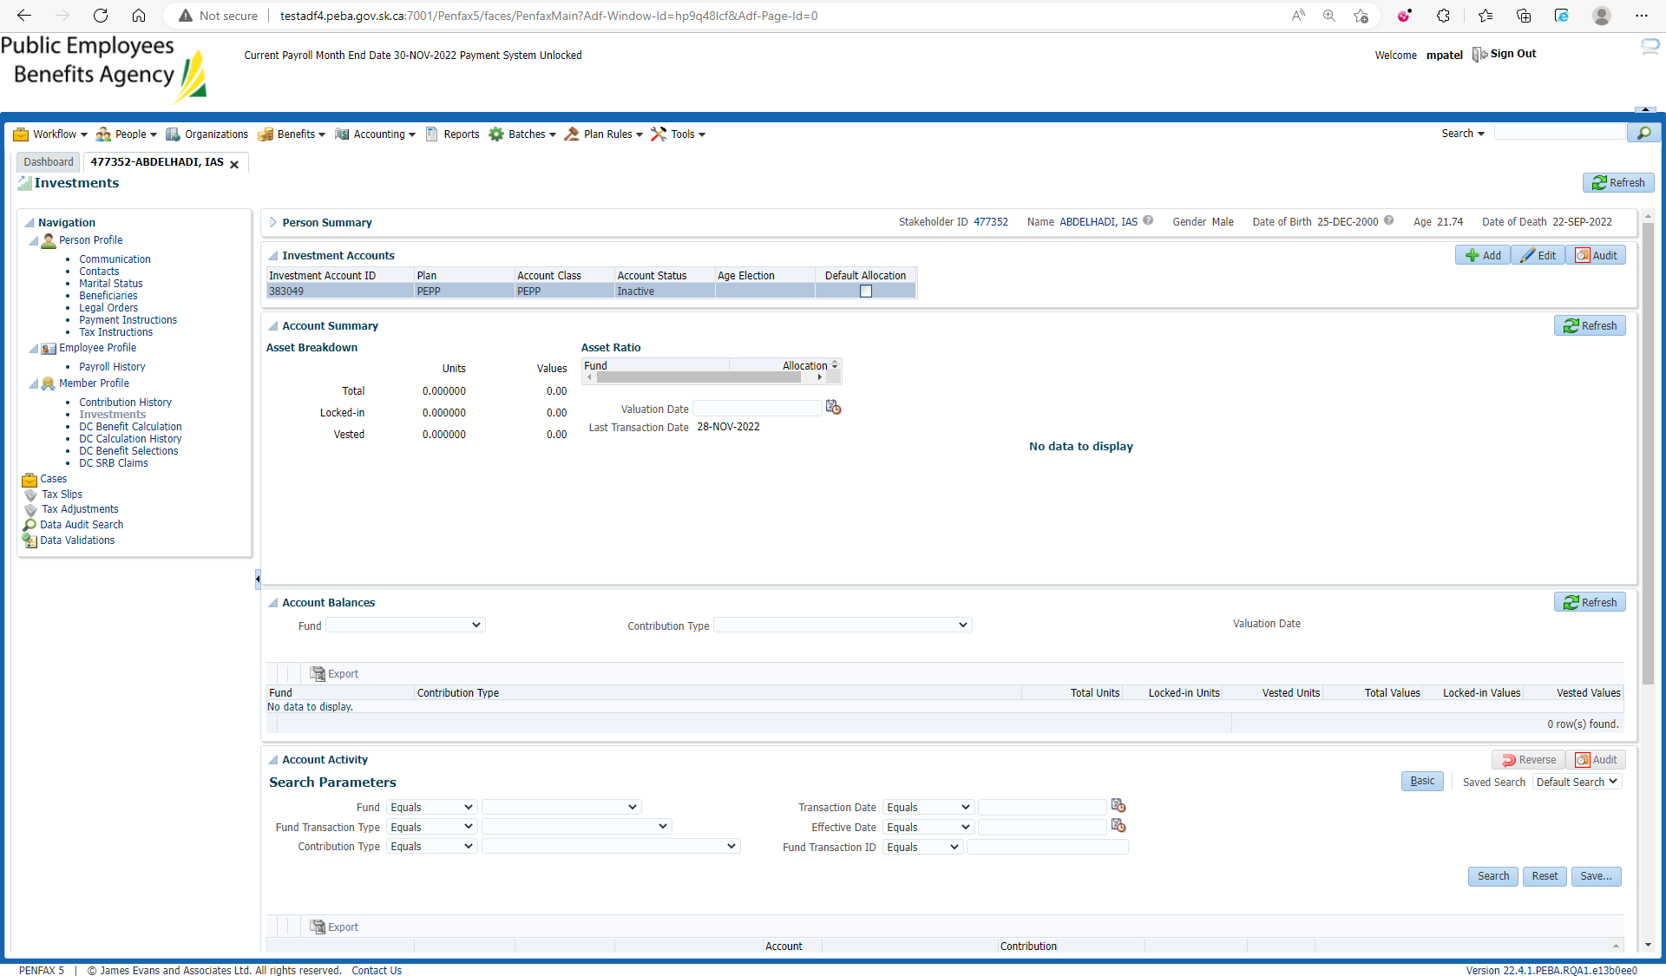

1. Go to the member profile. Make sure the member status is death.

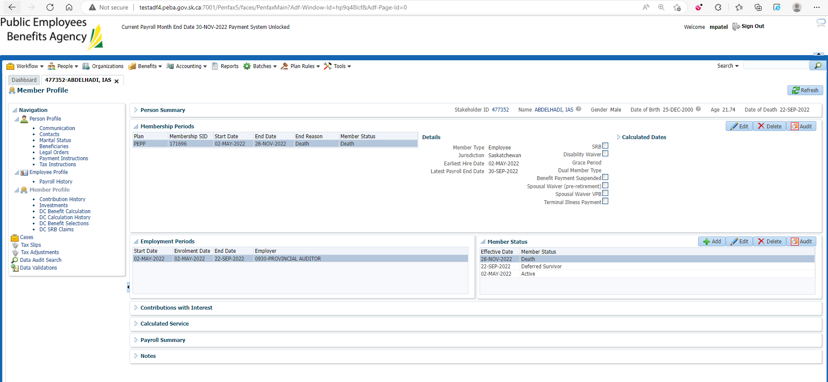

1. Bring up the Beneficiary stakeholder's account. Open the benefit recipient tab.

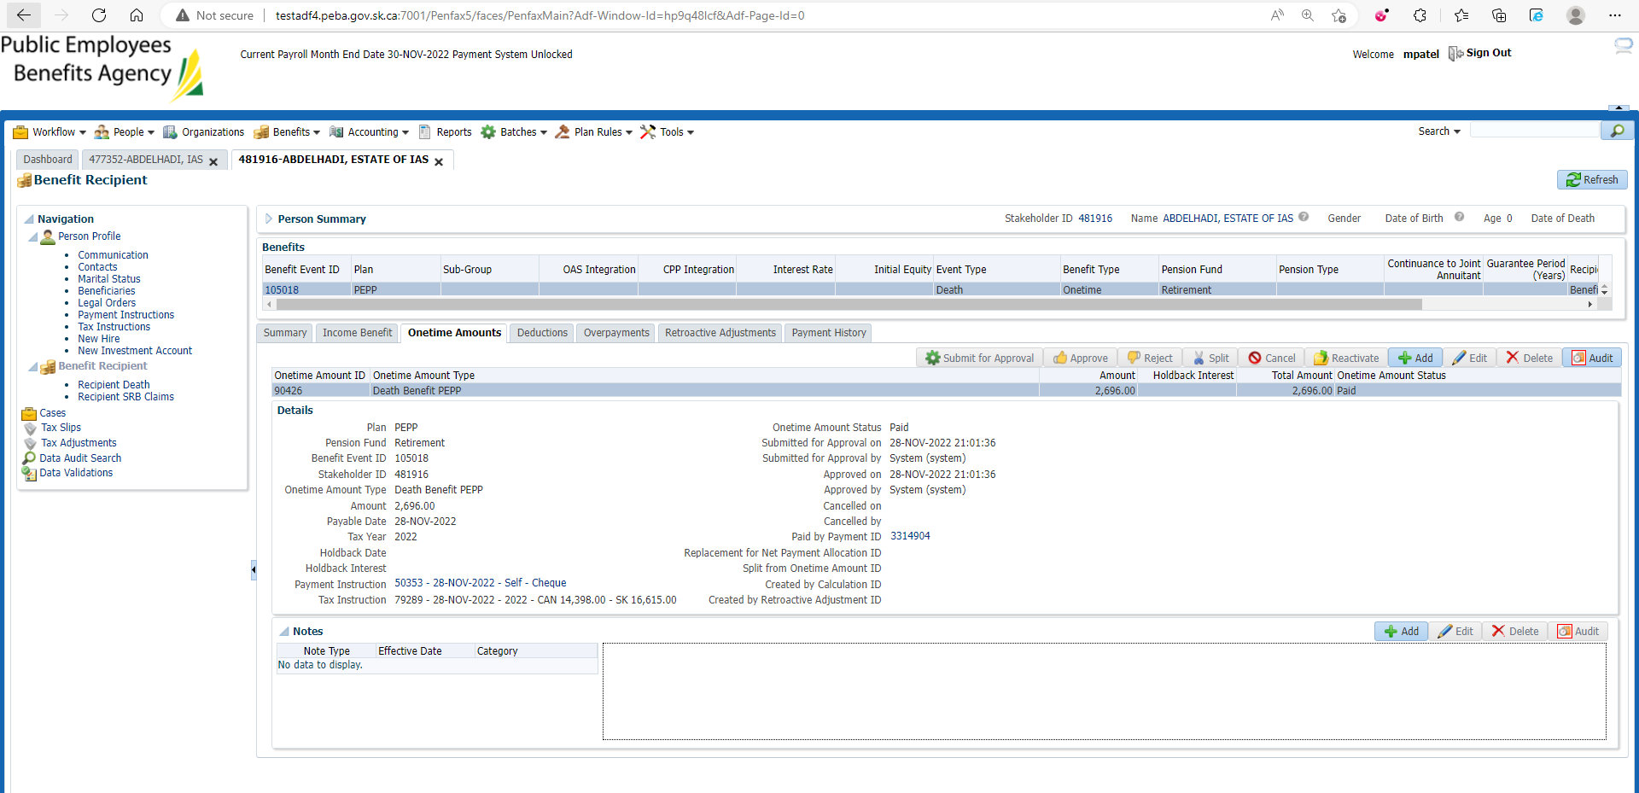

1. Go to communication tab. Under outbound documents there should be a PEPP Payment to Non-Member letter.

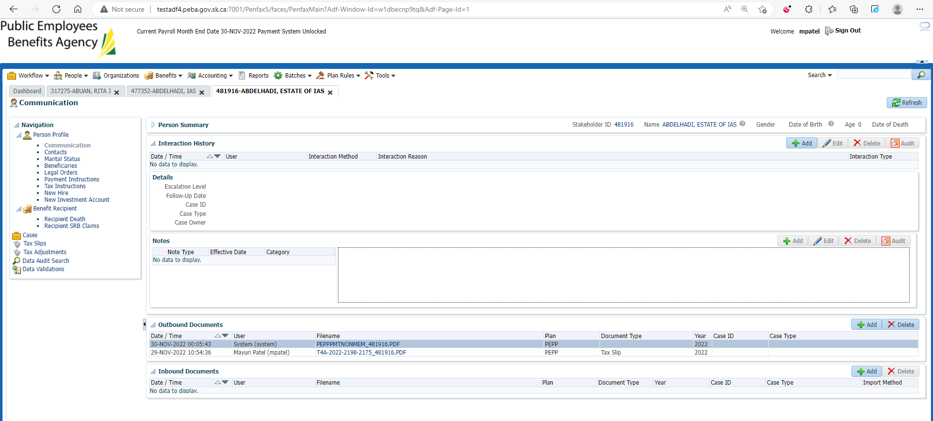

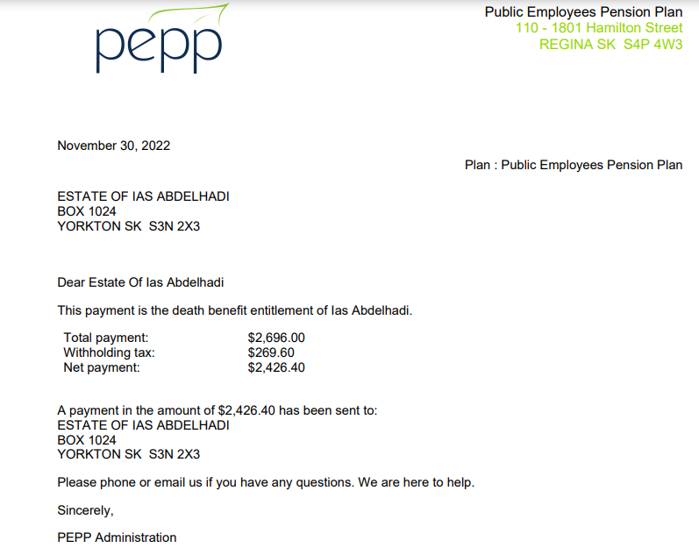

1. Click on Tax slips. There should be a Tax slip saved.

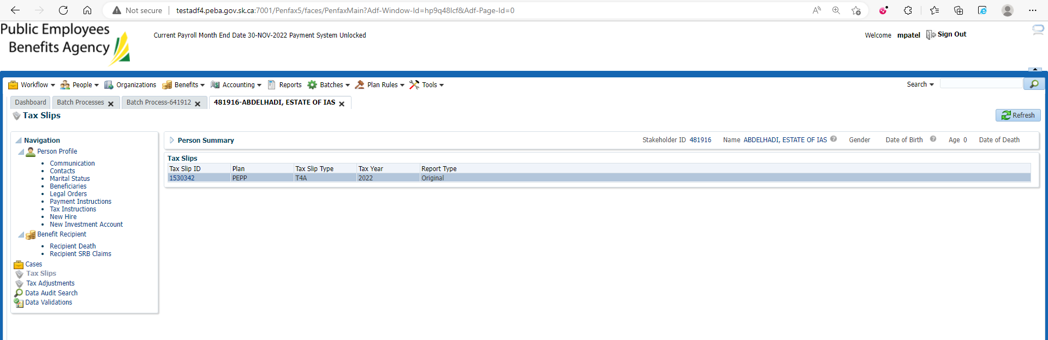

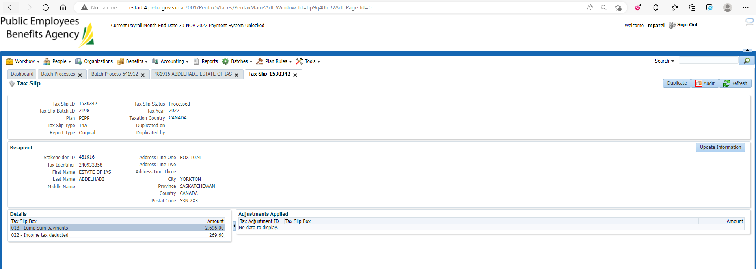

1. Go to Communication and you can see T4A generated there.

